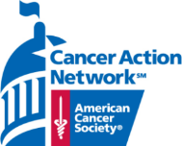
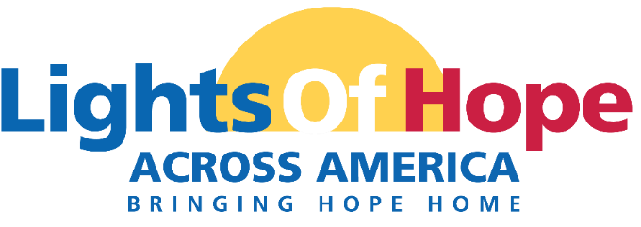

On September 18, 2021 the American Cancer Society Cancer Action Network (ACS CAN) will host its 11th annual Lights of Hope event. This year will be truly special as we celebrate ACS CAN’s 20th anniversary.
Each Light of Hope honors loved ones who have survived cancer and remembers those we’ve lost. The displays in communities from coast to coast will send a clear and impactful message to lawmakers that fighting cancer must be a national priority – from increasing funding for lifesaving cancer research to ensuring that all Americans in all communities have access to quality, affordable cancer care.

A look back at 2020:
- We displayed over 52,000 Lights of Hope across America shining at hundreds of home displays.
- We raised over $722,000.
- 19,600 views and counting of the Lights of Hope Across America Live broadcast.
- 1,857 public posts on Twitter and Instagram for our social media wall using #LightsofHope.

This event will be very powerful. Your support will help us light hope across America. We invite you to support the Lights of Hope event in the following ways:

Platinum Sponsor - $1,000
- 100 Lights of Hope bags to be personalized
- Company name listed as Platinum Sponsor on New York State webpage
- Logo featured on two lawn signs to be displayed in your community
- Logo Recognition on ACS CAN New York social media pages
- Recognition in ACS CAN's annual Advocacy Accomplishments Report
- Opportunity for name recognition in local press release

Gold/Family Sponsor - $500
- 50 Lights of Hope bags to be personalized
- Company name listed as Gold Sponsor on our New York State webpage
- Logo featured on lawn sign to be displayed in your community
- Recognition on ACS CAN New York social media pages
- Recognition in ACS CAN's annual Advocacy Accomplishments Report
Silver Sponsor - $350
- 35 Lights of Hope bags to be personalized
- Logo featured on lawn sign to be displayed in your community
- Recognition on ACS CAN New York social media pages
- Recognition in ACS CAN's annual Advocacy Accomplishments Report
Bronze Sponsor – $200
- 20 Lights of Hope bags to be personalized
- Recognition on ACS CAN New York social media pages
Thank you for considering this request. Please contact me if you have any questions or would like additional information.
Sincerely,

